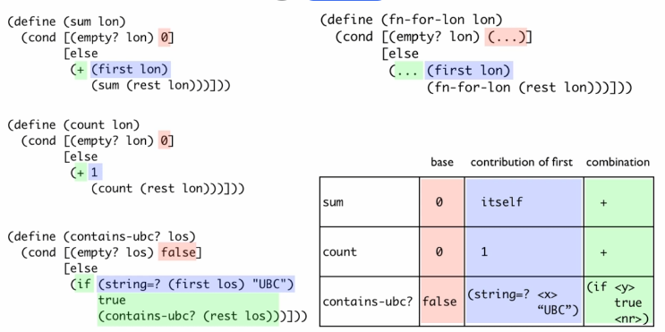

Red – base case result of the functions

Blue – contribution of the first element of the list to the result

Green – how the contribution of the first and result of the natural recursion are combined